II B. Tech II Semester Regular/Supplementary Examinations –May, 2024
OPERATING SYSTEMS
(CSE/CSE(AI&ML))
Time: 150 Min Max. Marks:80M

SECTION – A
Answer all Four questions 4×10M=40M
- Consider two data files, file1.txt and file2.txt, containing information about employees in a company. Each file has tab-delimited fields: employee ID (column 1), name (column 2), department (column 3), and salary (column 4). Develop a code to generate a report that compares the employee information from both files and presents it in a structured format.
- Specify the basic syntax and structure of regular expressions in Unix. What characters are commonly used as meta characters? [2M]
- Compare the employee information in file1.txt and file2.txt based on their employee IDs and display employees present in file1.txt, employees present in file2.txt and employees commonly present in both files. [2M]
- Sort each list alphabetically based on employee names. [3M]
- Identify 5 employees with minimum salary and add give 10% of their salary as bonus. [3M]

- Let us assume five philosophers who spend their lives in thinking and eating. The philosophers share a circular table surrounded by five chairs, each belonging to one philosopher. In the center of the table is a bowl of rice, and the table is laid with five single chopsticks (as shown in figure).
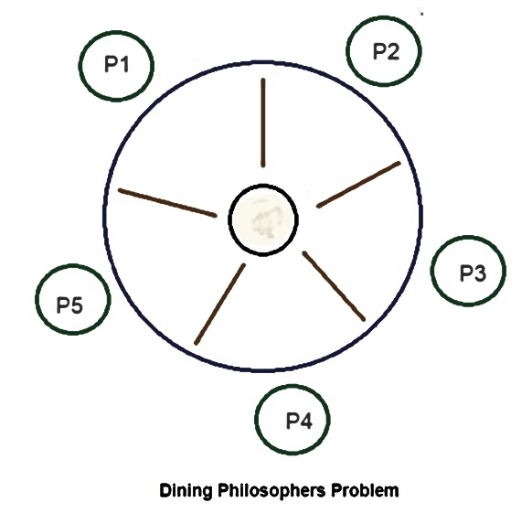
Examine the series of actions that each philosopher must undertake within the context of the Dining Philosophers problem.
- Identify the challenges inherent in this scenario and outline the problems that may arise during the dining process. [2M]
- Define the conditions under which a deadlock might occur and propose strategies for handling such situations. [3M]
- Explore the potential difficulties and trade-offs associated with employing various process synchronization techniques to address this problem. [2M]
- Design a logic for the Dining Philosophers problem. [3M]

- A simple segmentation of memory management system uses 16-bit virtual address with a maximum segment size of 8K bytes. The segment table for the currently running process has the following valid entries (all numbers in binary):
Segment number | Segment Length | Base Address
000 | 0000100000000 | 0100000000000000
001 | 1000000000000 | 1000000000000000
010 | 0000100000000 | 1100000000000000
011 | 0000000011110 | 1110000000000000
- Describe segmentation and its purpose in memory management. [2M]
- Explain the significance of virtual addresses in facilitating memory management in modern operating systems. [2M]
c) Convert the following virtual addresses in binary format to physical addresses. [3M]
(i) 0000000000010100
(ii) 0111110000000011
(iii) 1110001111100001
d) Write a short note on procedures to be adopted to resolve the limitations of traditional page-based systems. [3M]

- a) What is file mounting. Discuss different file mounting mechanisms used for any 3 different operating systems? [3M]
b) Given six memory partitions of 300 KB, 600 KB, 350 KB, 200 KB, 750 KB, and 125 KB (in order), Design an algorithm to implement how would the first-fit, best-fit, and worst-fit algorithms place processes of size 115 KB, 500 KB, 358 KB, 200 KB, and 375 KB (in order)? Compute the efficiency of an algorithms in terms of how efficiently they use memory. [3.5M]
c) Simulate various file protection procedures when content is sharing in any streaming applications like jio cinema, Netflix, voot, sonyLiv. [3.5M]

SECTION - B
Answer all Two questions 2×20M=40M
- a) Five batch jobs, A through E, arrive at a computer centre at same time with an estimated running time of 15, 9, 3, 6, and 12 minutes, respectively. Their (externally defined) priorities are 6, 3, 7, 9, and 4, respectively, with a lower value corresponding to a higher priority. Draw Gantt chart for each of the following scheduling algorithms.
  - Round robin with a time quantum of 1 minute [3M]
  - Priority scheduling [2M]
  - FCFS [2M]
  - shortest job first [3M]
b) Design an algorithm to determine waiting time of each process and turnaround time of the scheduling algorithms mentioned in (a). [7M]
c) Based on calculation from (b) which scheduling algorithm is best. Justify your answer. [3M]

- a) List the basic strategies for deadlock prevention in operating systems. [3M]
b) Develop a resource allocation policy for a system to prevent deadlock based on specific requirements and constraints. [3M]
c) Consider the following snapshot of a system: [7M]

Process | Allocation  A B C D | Max  A B C D
P0 | 3 0 1 4 | 5 1 1 7
P1 | 2 2 1 0 | 3 2 1 1
P2 | 3 1 2 1 | 3 3 2 1
P3 | 0 5 1 0 | 4 6 1 2
P4 | 4 2 1 2 | 6 3 2 5
Using the banker’s algorithm, determine whether or not each of the following states is unsafe. If the state is safe, illustrate the order in which the processes may complete. Otherwise, illustrate why the state is unsafe.
i. Available = (0, 3, 0, 1) ii. Available = (1, 0, 0, 2)
d) Design a simulation model to demonstrate the operation of the Banker's algorithm in a resource allocation system, including processes, resource types, and allocation requests. [7M]

